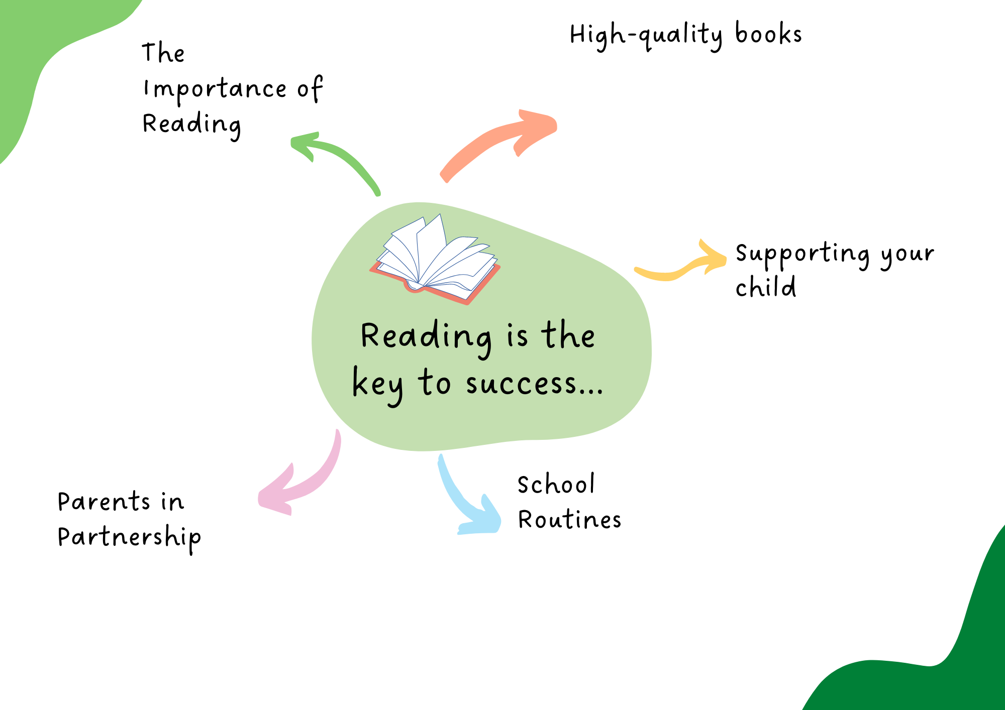
It is crucial for both school and parents to actively teach their child to read. We need you to create a home environment where reading is encouraged and seen as a pleasurable experience.

Spending just 10-15 minutes reading with your child every day will be invaluable in developing their ability and desire to read and learn.

- Your child's reading book will be changed in line with their RWI routine or when they have completed their reading book
- Home Liaison Books are checked daily and we ask you to complete

- Read at least 3 times per week with your child
- Log your child's reading in their Reading Record so that they can access school rewards
- Make reading time pleasurable by finding a quiet, comfortable space and giving your child your full attention.
- Ask your child simple questions as they read to check their understanding
- Use positive language and praise their reading efforts
- Read to your child as part of your evening routine. This builds vocabulary, feeds imagination and can even improve sleep patterns
- Ask them about books/ stories they are reading at school (your child's class books are shared on the half termly overviews)
We will ensure that your child has a reading book which is suitably pitched to build both confidence as a reader and fluency.
We will also provide your child with a free-choice book from their class library for enjoyment. Allowing children free choice helps them to develop their identities as a reader as they learn which books/ authors they like and which they do not.
For highly competent readers we will support their exploration of books through our new Reading Challenge Trees, which start from Year 2.

The importance of reading for children cannot be underestimated. Reading for pleasure can benefit a child’s education, social and cognitive development, their wellbeing, and their mental health.
Engaging with books allows us to be transported to other places and worlds. We can become immersed in the lives of fictional characters or learn more about the world around us.
Reading is a key life skill. It is placed at the heart of our curriculum; we have carefully selected texts which will ignite children's imagination, inspire their curiosity and provide a window to the world.
It is commonly said that a child’s future academic success and job prospects are directly related to their reading proficiency.

