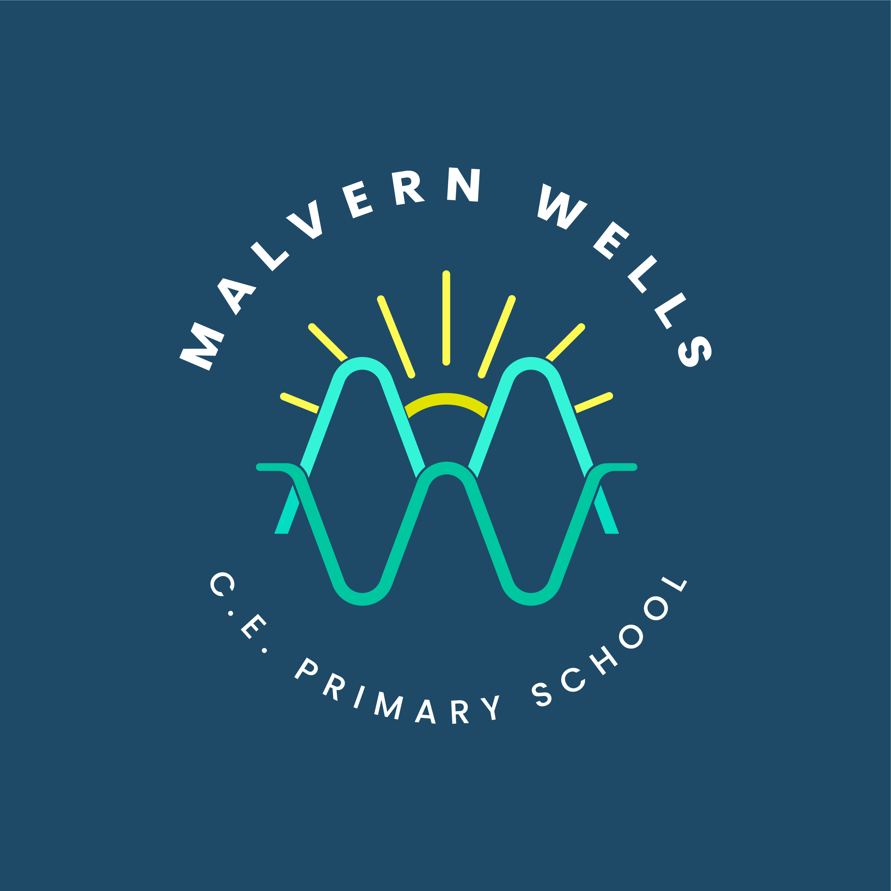
Geography at Malvern Wells

Intent
Subject Aim | At Malvern Wells CE Primary School, geography helps children Let Their Light Shine by understanding their place in the world, investigating how places work and making thoughtful decisions about our shared environment. Pupils learn to locate, describe, compare and explain using geographical evidence.
Curriculum Design | The mixed-age two-year curriculum builds component knowledge towards three composite outcomes in each unit. KS1 develops local observation, UK and world location, human and physical features, weather and simple maps. LKS2 deepens regional comparison, land use, weather and climate, tectonic and coastal processes, directions and grid references. UKS2 connects biomes, rivers, settlement, economic activity and sustainability through regional evidence and increasingly systematic fieldwork.
End Points | By Year 6, pupils explain relationships between physical processes and human decisions; compare named regions using matched evidence; use maps, latitude, longitude and grid references; collect and interpret fieldwork data; and recognise the limits of their conclusions.
Threshold Concepts | Place • Space • Scale • Physical and human processes • Interdependence • Environmental impact • Sustainable development
Golden Threads | Location and place knowledge • Human and physical connections • Maps and geographical representation • Fieldwork and evidence • Change and sustainability • Accurate comparison without stereotypes

Implementation
Timetabling | Teach the agreed mixed-age cycle in planned enquiry units, including the fieldwork specified in the MTPs. Check entry knowledge in either cycle rather than assuming the other cycle has been taught.
Lesson Structure | Do It Now retrieval → Apply It using secure earlier knowledge in a fresh context → Enquiry and explicit teaching → Modelled and guided geographical practice → Independent application → Review against the Can I question.
Non-Negotiables | - Teach the identified component knowledge, with no more than three essential components per lesson, building towards the coloured composite outcomes.  - Begin every lesson with retrieval.  - Provide flexible application of secure prior knowledge in a different context.  - Revisit the location of studied places and explicitly teach, revisit and apply geographical vocabulary.  - Teach geographical distinctions accurately, including human and physical features, weather and climate, and observation and explanation.  - Compare places using matching categories. Link observations and evidence to specific locations, support conclusions with evidence and recognise its limitations. One photograph or example cannot represent an entire region.
Teacher Expectations | Prepare maps, sources and fieldwork methods; model geographical reasoning and check misconceptions. Make connections from Malvern Wells and the West Midlands to studied places, including Worcester, Tulum, Campania, Brazil and California.
Assessment | Use retrieval, map reading, discussion, observations and composite outcomes to identify insecure knowledge. Apply the separate year-group expectations and revisit misconceptions before adding demand.
Vocabulary | Explicitly teach and apply location, settlement, land use, weather, climate, biome, ecosystem, erosion, transport, deposition and sustainability, alongside each unit’s precise vocabulary.
Adaptive Teaching | Adapt map complexity, source presentation, equipment, prompts and recording while retaining the enquiry and essential knowledge. Accept spoken, drawn and practical evidence; increase independence as scaffolds are withdrawn.
Resources and Enrichment | Use agreed MTPs and aligned Grammarsaurus resources, atlases, globes, aerial photographs, OS maps, instruments and matched data. School grounds, Malvern landscapes and the Severn provide purposeful local observation and fieldwork contexts.

Impact
Assessment | Check whether pupils recall geographical knowledge and use it to explain a new example. Conclusions must match the available evidence; a completed worksheet alone does not establish understanding.
Evidencing Progress | Maps, located observations, field sketches, tables, graphs and explanations show progression from naming and describing to explaining relationships, comparing evidence and evaluating limitations.
Pupil Voice | Pupils explain where a studied place is, what shapes its character, how it connects with people and environments, and which evidence supports their conclusion.
Monitoring and Evaluation | Subject leaders review MTP fidelity, fieldwork, work samples, pupil discussion and year-group outcomes. Check that recurring knowledge becomes more secure and either-cycle entry remains accessible.

