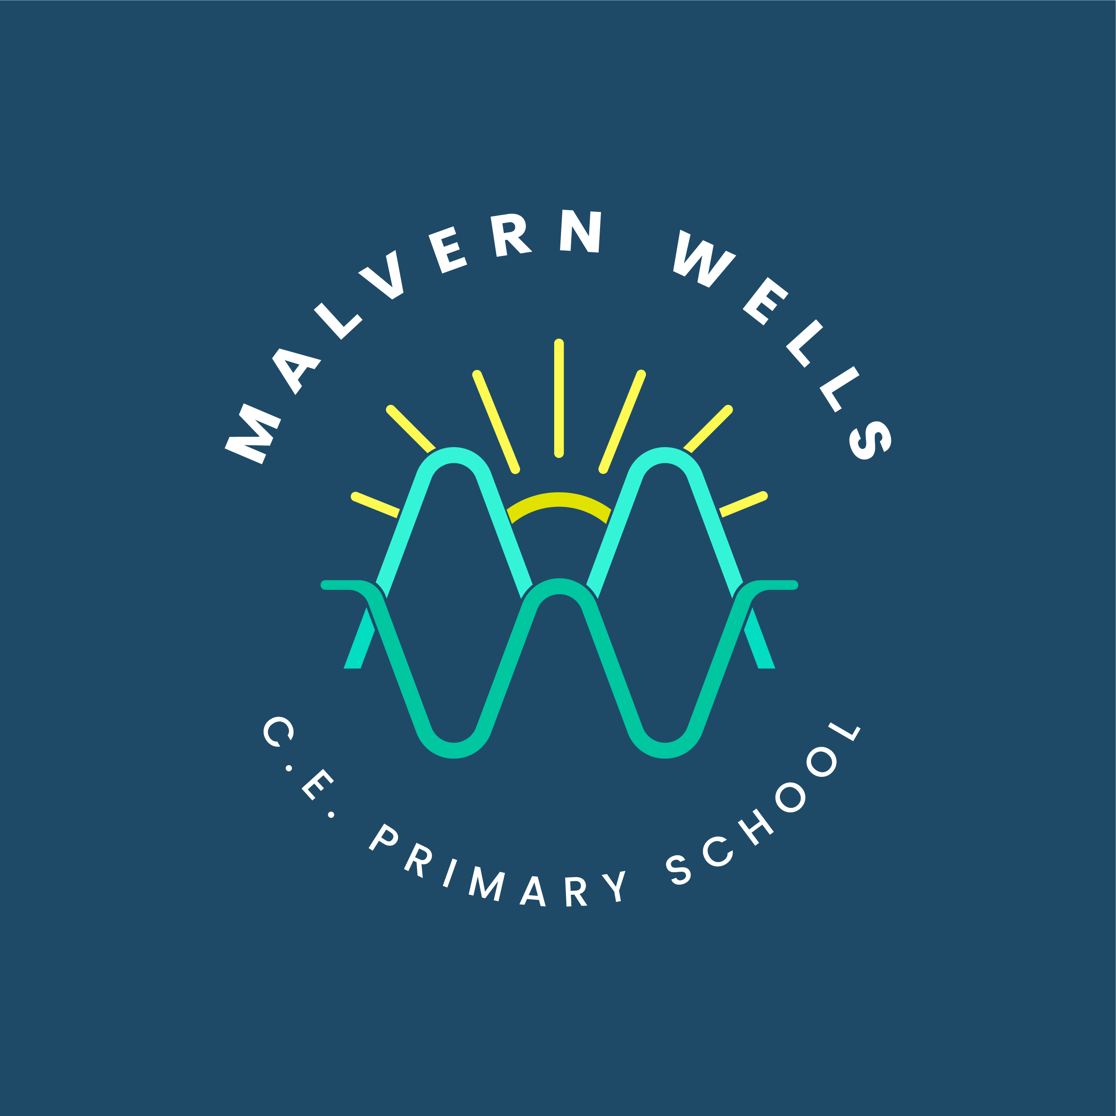
Art and Design at Malvern Wells

Intent
Subject Aim | At Malvern Wells CE Primary School, art enables every child to Let Their Light Shine through observation, imagination and personal expression. Pupils develop technical control, learn from artists and craft makers, and explain deliberate choices through their own creative work.
Curriculum Design | The mixed-age two-year curriculum builds three composites in each unit.  KS1 develops line, shape, pattern, colour mixing, collage and clay shaping or relief.  LKS2 deepens observation, value, texture, perspective, watercolour, sketchbook trials, mixed media and secure clay construction.  UKS2 develops drawing style, facial proportion and form, portrait and environmental intentions, colour relationships and supported sculpture. Each cycle teaches its new techniques explicitly.  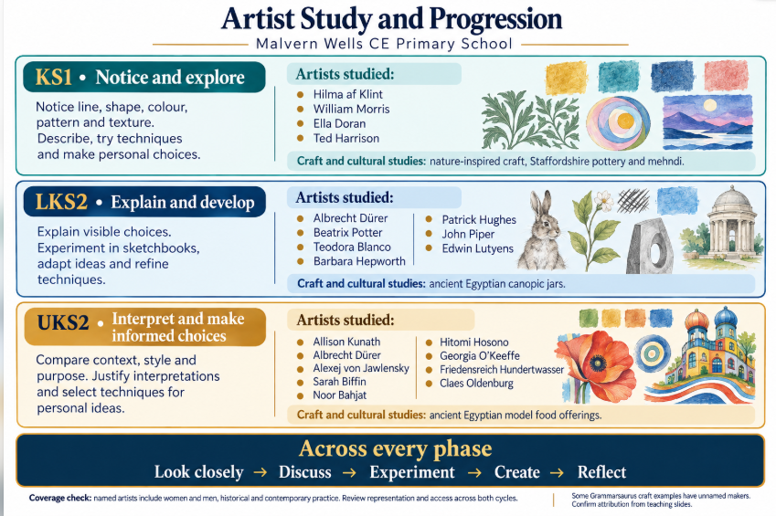
End Points | By Year 6, pupils observe and compare carefully, select and control techniques across drawing, painting, collage and sculpture, and use trials to develop personal intentions. They explain artist influence, justify choices through visible evidence and refine specific features.
Threshold Concepts | Visual elements • Observation and representation • Materials and technique • Artist influence and context • Personal intention • Experimentation and refinement
Golden Threads | Visual elements • Materials and techniques • Artists and contexts • Ideas and creative decisions • Developing and refining • Responding and evaluating

Implementation
Timetabling | Teach the agreed drawing, painting and sculpture units in each mixed-age cycle. Allow practice, drying, finishing and evaluation time. Check shared foundations without requiring completion of the opposite cycle.
Lesson Structure | Do It Now retrieval → Apply It transferring a secure earlier skill → Can I and explicit teaching → Demonstration and guided experiment → Personal practical application → Review and refinement. Retrieval is practical or oral; UKS2 includes MC and true–false checks.
Non-Negotiables | Teach no more than three components per lesson towards the coloured composites. Explicitly model technical vocabulary and control. Use accurate artist and cultural contexts. Preserve personal decisions; inspiration does not require copying. Do not assess artistic success by neatness or identical outcomes.
Teacher Expectations | Prepare the selected artworks and test materials or processes. Model observation, technical trials and revision. Make visible connections from familiar marks and mixtures to proportion, depth, expressive choices and three-dimensional construction.
Assessment | Use experiments, sketchbook development, practical work and brief explanations against separate year-group expectations. Check mixing, joins and technique through the process, because the finished artwork alone cannot establish them.
Vocabulary | Teach and revisit line, shape, colour, texture, value, form, pattern, composition, proportion, perspective, watercolour, collage and sculpture, alongside each unit’s precise technique vocabulary.
Adaptive Teaching | Adapt grip, tools, scale, materials, visual prompts and recording while retaining the artistic intention and child’s choices. Accept pointing, gesture and recorded speech. Extend challenge through comparison, control and justified refinement.
Resources and Enrichment | Use MW MTPs, aligned Grammarsaurus resources, attributed artworks, photographs, drawing tools, paint, collage and clay materials. Study selected examples including Hilma af Klint, Ted Harrison, Dürer, Beatrix Potter and Patrick Hughes; connect observations with personal work.

Impact
Assessment | Look for increasingly purposeful technique and choices pupils can explain. Separate visible evidence from interpretation. Different viewers may respond differently; an environmental artwork’s intended message is not proof of changed behaviour.
Evidencing Progress | Trials, sketchbooks, drawings, paintings, collages, sculptures and process photographs show increasing observation, technical control, independence and refinement across media.
Pupil Voice | Pupils identify an observed artist feature, explain what they adapted, justify a material or technique and describe how a specific revision changed the result.
Monitoring and Evaluation | Subject leaders review MTP fidelity, practical outcomes, sketchbook or trial evidence, pupil discussion and year-group end points. Check that recurring knowledge supports new intentions and pupils retain ownership of creative decisions.

